## Migracion.2.SUI módulos. datos SIM

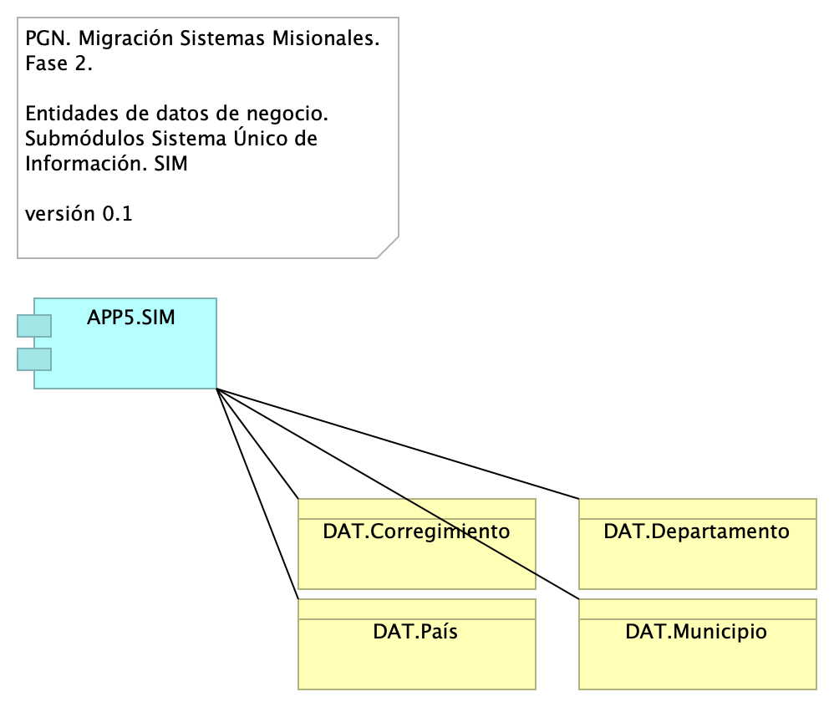

Figure 1: Diagram: Migracion.2.SUI módulos. datos SIM

### Catálogo de Elementos

| Name | Type | Description | Properties |
| --- | --- | --- | --- |
| **APP5.SIM** | application-component |  |  |
| **DAT.Corregimiento** | business-object |  |  |
| **DAT.Departamento** | business-object |  |  |
| **DAT.Municipio** | business-object |  |  |
| **DAT.País** | business-object |  |  |